PRESS RELEASE

Lawrie Shabibi presents MIND’S EYE
a solo exhibition by the renowned Turkish artist
SELMA GÜRBÜZ
24 October, 2011 to 7 December, 2011

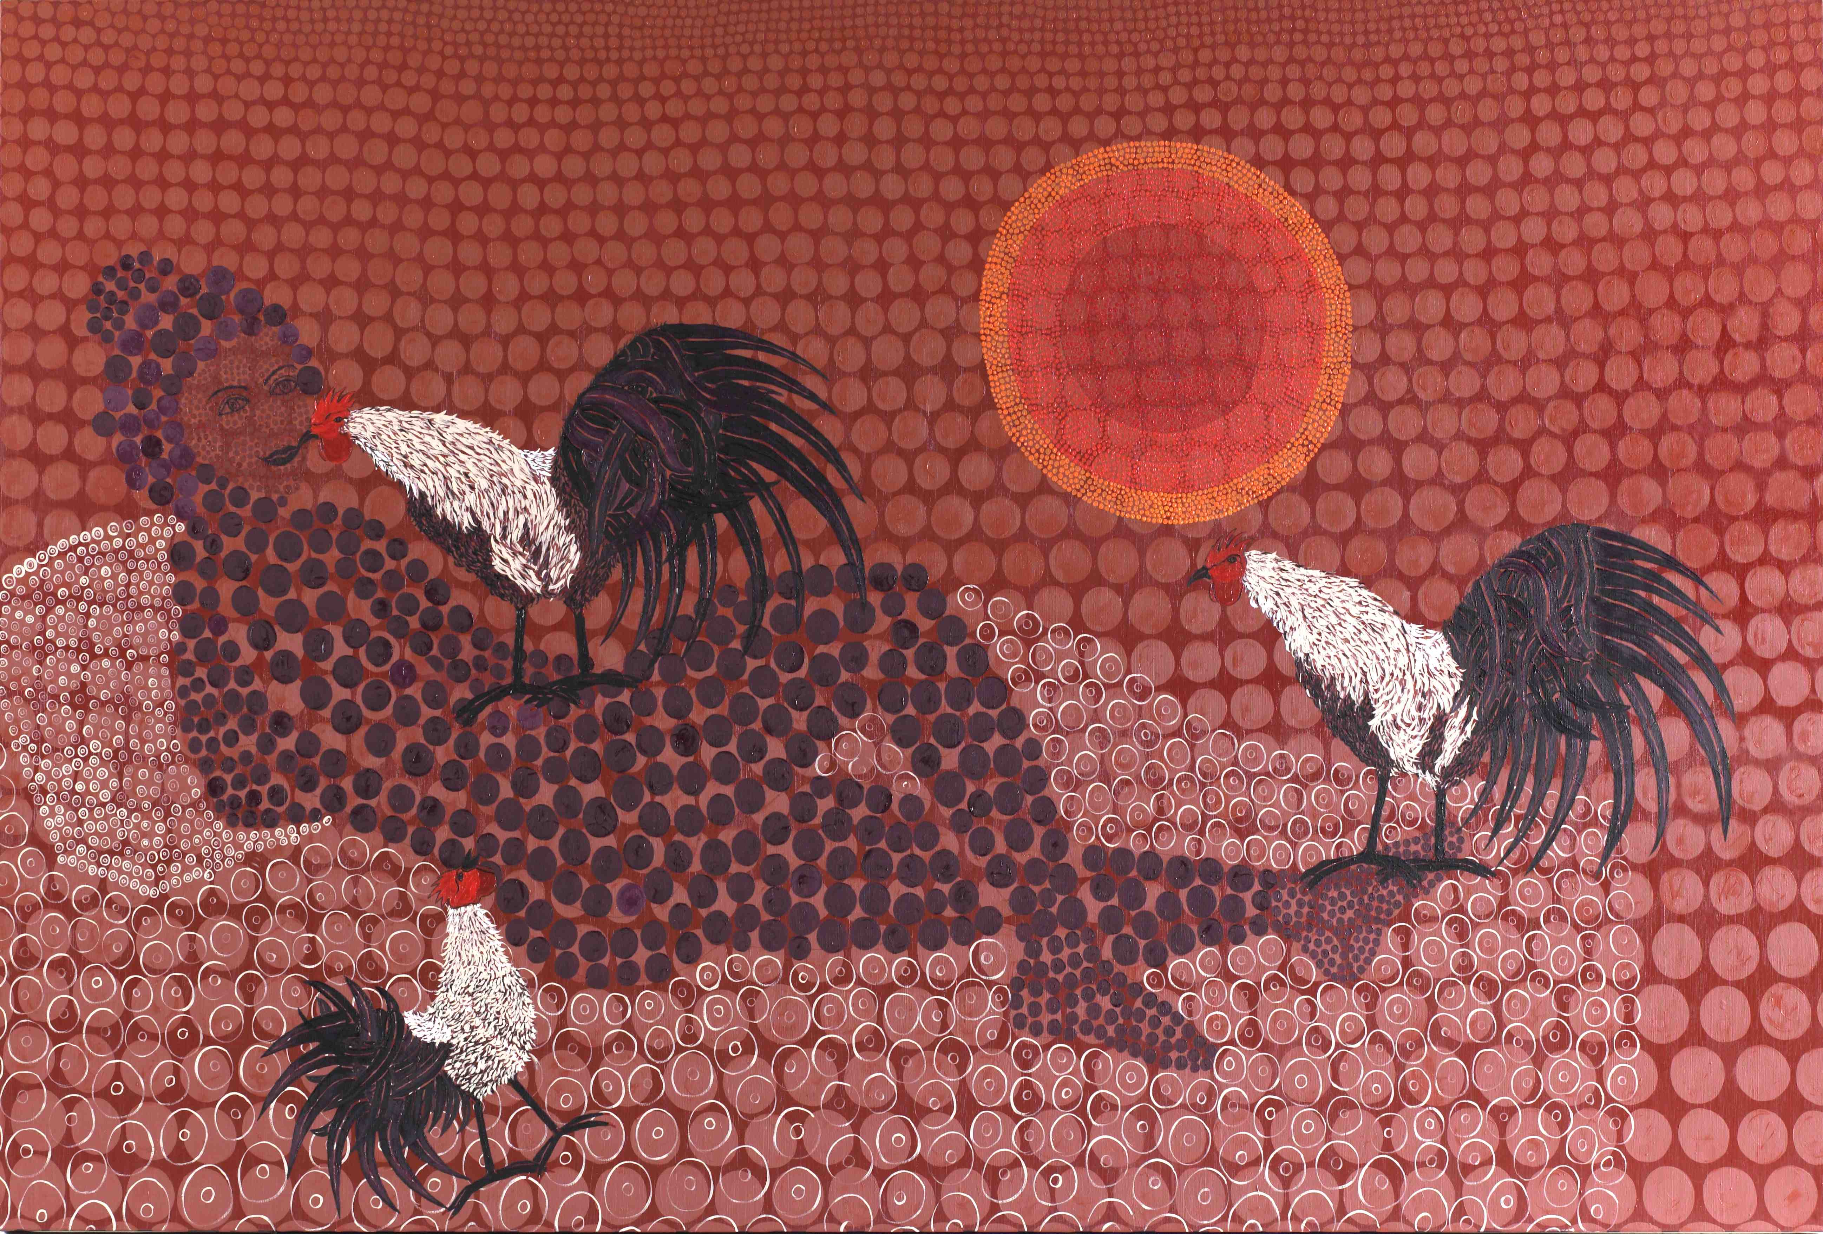

In association with Zurich and Dish, Lawrie Shabibi is pleased to announce Mind’s Eye, the first solo exhibition in the Gulf Region for Selma Gürbüz, one of Turkey’s foremost contemporary painters. Working in a grand scale in oil on canvas and more intimately with ink on paper, this exhibition combines both aspects to give an overview of her recent work.

In her rich and evocative paintings Selma Gürbüz draws on a broad range of influences and merges them with her whimsical imagination to produce lyrical and very personal works. Each of her paintings is touched by romanticism and her own esoteric story-telling. Selma Gürbüz is nothing if not eclectic. She knows her sources and is not afraid to mix idioms. Just as the mind links remembered images and events, she intuitively weaves together disparate elements in her paintings. Gürbüz leaves the line that separates intention from intuition deliberately obscured, so that her paintings bear a strangely familiarity through an unfamiliar melding of disparate parts, a kind of fairytale mythology based on our collective cultural memories.

Selma Gürbüz’s work carries echoes of high Ottoman and traditional Turkish folk art, with combinations of motifs that are uniquely Turkish and rooted in the culture of the country. The all-over patterning of Iznik tiles and silk embroideries feeds into her paintings, with their vegetal arabesques and cintimani, as do the bold outlines of Turkish Karagoz shadow theatre. Within the same paintings she introduces elements from the pantheon of Western art, with elements from Cranach, Leonardo, Velazquez and Goya, and the formal qualities of Ingres, Manet and Mattise, while at the same time she looks East, beyond Turkey. Persian miniatures, Japanese woodcuts and Indian sculpture all inform her work. It is this ability to seamlessly draw together features from high and folk art from a wide range of sources, both geographical and temporal, and her tendency to combine different aspects within individual elements that makes the work of Selma Gürbüz so uniquely mesmerizing.

“The idea of ​​holding the exhibition in Dubai is very special to me, because I have many influences from eastern art. It is very important to me that my work will be exhibited in this culture, in this land, in this region.

"The exhibition that I am going to hold at Lawrie Shabibi Gallery in Dubai mostly consists of works I had made in my studio in Istanbul in 2011. I always put a full stop after each exhibition and begin with a new clean sheet. Actually, the things that should have been said were told in the first few sentences, but the real sentence is still incomplete. What brings me to the process of this second exhibition is the need to complete this sentence. Before that, I held an exhibition called Shadows of Myself at Leighton House Museum in London. Now, with this exhibition, I will continue to form the incomplete sentence. I think that the Western tradition and the tradition of the Eastern pole are actually two separate fluid materials intertwined. I try to imagine the West from the East as how west would imagine east.
When setting up my own dream, I generate a view from east to west by knowing both the western art and culture and using the richness of this region such as being in between East and West. When I interpret Western myths through the eyes of the eastern, the Eastern myths that I have created show up, too. They also have a nature that occurs with these myths. There is not an indication on a definite location. Geographies are undefined in my pictures.”
Selma Gürbüz.

This exhibition is held in association with Zurich and Dish.

About Selma Gürbüz
Selma Gürbüz was born in Istanbul in 1960. She studied for her BA in Fine Art at the Exeter College of Art Design in the UK (1980-82) and at the Marmara University School of Fine Arts in Turkey (1982-84). She has exhibited extensively both in Turkey and abroad and is one of Turkey’s best-known contemporary artists.

Recent solo shows include Shadows of My Self with Rose Issa Projects at Leighton House, 2011; “Aketip” (“Archetypes”), Antrepo no.3, Istanbul (2010); “Uninvited”, Akbank Culture Center, Istanbul (2009); “Sunny Shadows III”, Gallery Apel, Istanbul (2008); Galerie Maeght, Paris (2008); “Cat’s Eye”, Milli Reasurans Gallery, Istanbul (2008); “Kamiyama Workshop”, Kamiyama, Japan (2007); “Safa”, MAC Art Gallery, Istanbul (2007); “Feline I”, Galerie Maeght, Paris (2006); “Feline II”, Gallery Apel, Istanbul (2006); “Go East”, Beijing TSI1 Contemporary Art Center, Beijing (2006); “Daydream”, Gallery Nev, Ankara (2005).

Her work is in public collections which include The British Museum, London; Istanbul Modern; Santral Istanbul; Istanbul Bilgi University; Project 4L, Istanbul; Galerie Maeght, Paris; and the Painting and Sculpture Museum, Ankara.

About Zurich

Zurich is a leading insurance provider with a global network of subsidiaries and offices in Europe, North America, Latin America, Asia-Pacific and the Middle East. It offers a wide range of general insurance and life insurance solutions for individual and corporate customers. Zurich has recently launched a bespoke proposition for high net worth individuals in the Middle East, providing insurance solutions tailored to the unique lifestyles of this niche group of customers. Zurich offers insurance for luxury cars, homes, yachts, art and valuables.

About Dish

Dish is one of Dubai's most reputable boutique catering and event management companies. Since opening in 2008 Dish has organized and catered for numerous high profile functions ranging from 20 to 700 people. Dish is a dynamic leader in the premium catering business, recognized for it's modern cuisine and spectacular events. For more information please visit the website www.dish.ae or call 04 422 1613.

About Lawrie Shabibi

Lawrie Shabibi is an exciting new contemporary gallery located in Dubai’s Al-Quoz industrial district focusing on both established and emerging contemporary artists from the Arab world, Iran, North Africa, South Asia and Turkey. Founded in 2010 by William Lawrie (former director of contemporary art at Christie’s) and Asmaa Al-Shabibi (former managing director of Art Dubai), the gallery engages the public with art that imparts a cultural and political discourse together with a powerful aesthetic.

Further information on Lawrie Shabibi can be found at www.lawrieshabibi.com.

Lawrie Shabibi
Alserkal Avenue, Unit 21
Al-Quoz
PO Box 123901
Dubai
info@lawrieshabibi.com
+971 43469906
Opening Hours: 10am to 6pm Sunday to Thursday. Saturdays by appointment.
For media enquiries please contact
Joud Malhas at joud@lawrieshabibi.com +971507754073

